Project Management Tool Evaluation
John Murray
IT343 – IT Project Management
Professor Therrien
7/11/2025
George Mason University

Project Management Tool #1 - Clickup
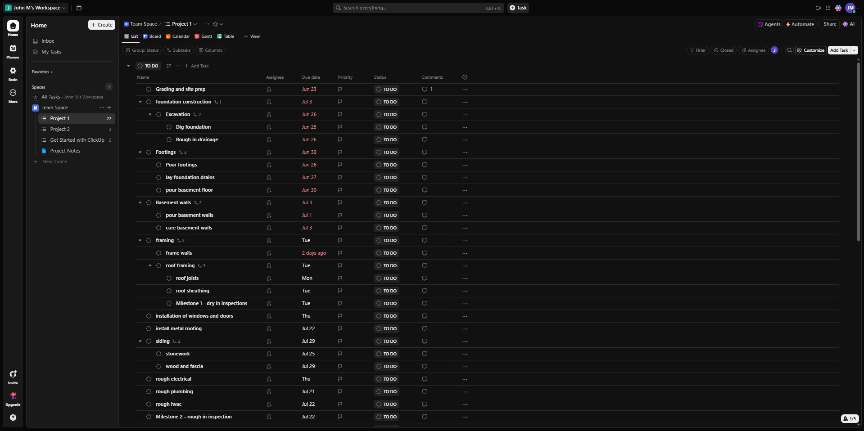
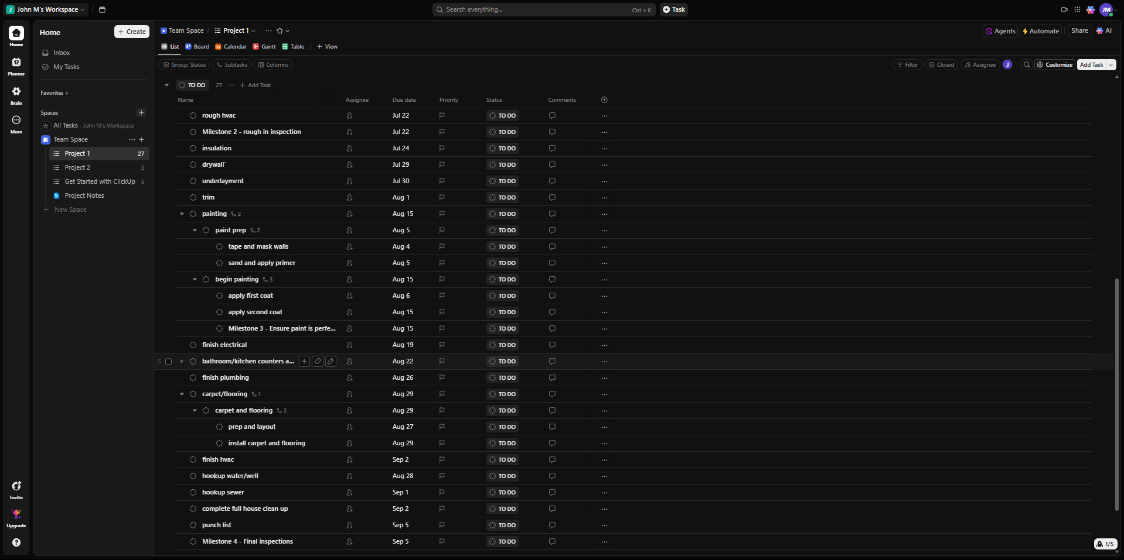
This screenshot was after I input all the task names, with their subtasks and start/due date. Unfortunately, in my using of Clickup there was no display of the start dates that I could find, and it only displayed the due dates even after inputting the start dates for each task. I also added the milestones into the sheet and the dependencies/predecessors were very odd to use and I found them unusable for the project.
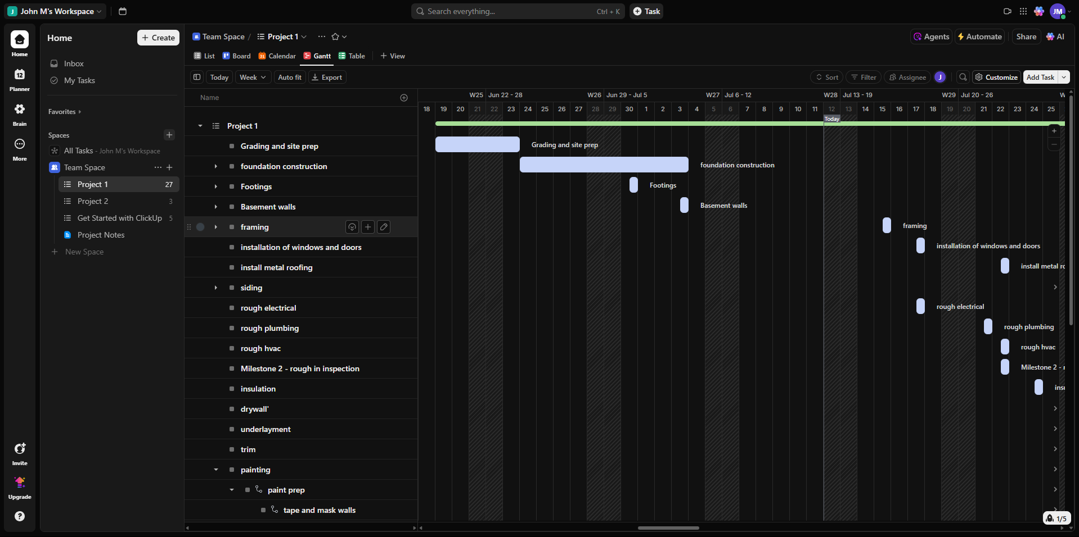
Pros –
- Flexible structure allows for detailed organization
- The Gantt view is appealing and easy to read
- More suited for complex projects
- The collaboration tools could be very helpful to teams
- Has good resource management reading
Cons –
- Contains a decent learning curve when a new user
- Some of the advanced features are lessened due to the free version
- It was overwhelming to use due to the abundance of features
- The interface is lots to take in at once when completing a project.
Lessons learned from ClickUp – Clickup seems to be a powerful tool for project management and could possibly be suitable for capstone projects.
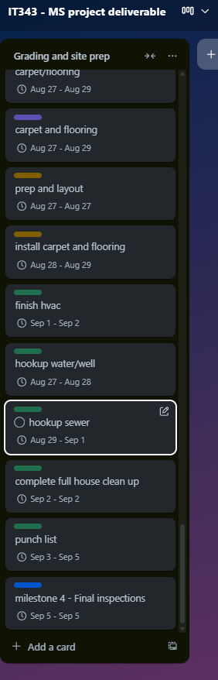
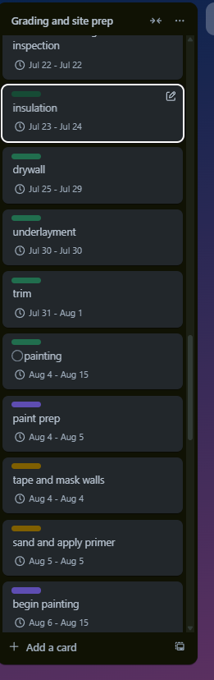
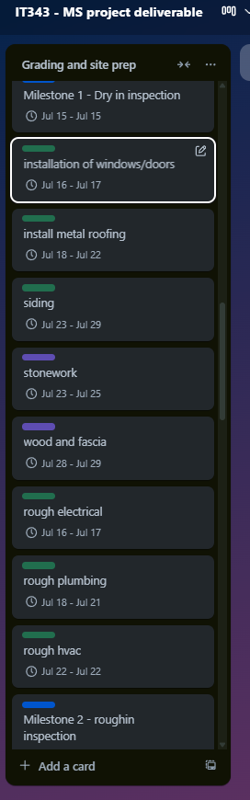
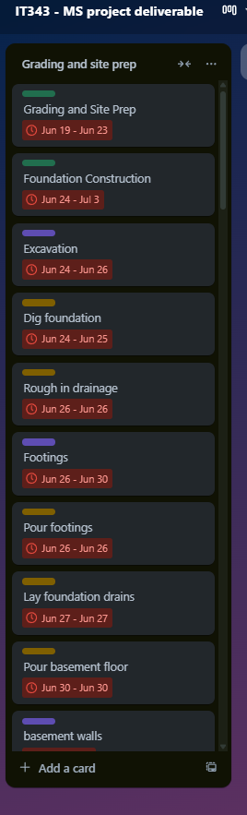
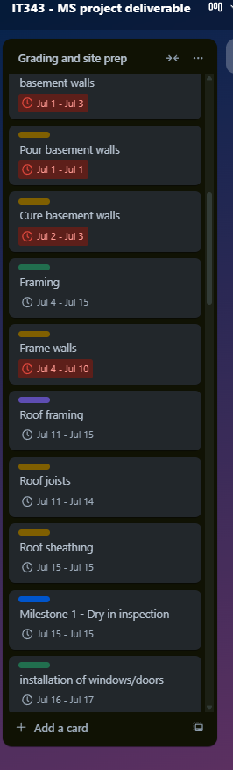
Project Management Tool #2 - Trello
In the above screenshots I used the project management tool Trello, this is my list/project. After inputting all of my tasks from the MS project deliverables, I then proceeded to run into an issue with there being no subtask options without an addon, so I added a color-coded way of titling each task. The green tab on the task indicates that the task is a main task, the purple tab indicates the task is a subtask from the main green one. The brown/yellow tab indicates the task is a subtask to the purple task, and finally the blue tab indicates that it is a milestone. The start/end dates have been added, and the durations of the task have their respective lengths.
Pros –
- The interface is clean and was easy to learn
- The team collaboration looks seamless
- The free version was enough to perform my needs
- The setup was fast, and the program was flexible
- The color coding is a great addition
Cons -
- The setup for the dates and the tasks were all manual
- The difficulty of managing large projects is high
- To gain access to a Gantt chart or timeline you need a third-party powerup
- Unable to create linked subtasks without third-party powerup
- The interface is too minimal
Lessons learned from Trello – Trello seems more ideal for a small project with a team on the smaller side, Trello seems to lack extensive project management features but is easy to use and good for basic planning.
Evaluation and Comparison
After using Trello, Clickup, and Microsoft Project, I’ve seen the strengths and weaknesses of each program. Microsoft project is considered the standard for project management and can be seen in the in-depth tools that can be used for budget tracking, resource allocation, and setting predecessors to tasks. After the weeks that we worked on the Microsoft Project deliverables, the learning curve of MS Project is clear to see, a similar comparison of learning curve would be to Excel but Project is a steeper learning curve. If not for George Mason’s remote desktop for students then the license for the program would be pricey and is best suited for organizations with many teams and members where precision and accuracy is required.
In comparison, Trello is opposite to MS project in the ways that the interface is laid out and aiming for a visual aesthetic for the team to easily follow. This program is best suited for any teams that are more focused on the basic tracking of tasks and milestones rather than intensive resource allocation or planning. Trello’s program does not require much practice to get the hang of resulting in a perfect program for phases early on in the project management and creation processes. Some shortcomings that could be seen in Trello are when you must have specified task predecessors or tracking of progress, the program cannot create any Gantt charts without the use of third-party “powerups”, which is what they are called. Due to lacking these features, I would say that Trello would be unsatisfactory for a capstone level project.
ClickUp is a middle ground between Trello and MS Project, the program has the aspect of simplicity to an extent and also the complexity of MS Project if needed. For the average student team managing a project in IT492 and IT493, ClickUp seems to be a solid choice out of the project management tools that I used. With the support of well-made dependency tracking, time-estimates, and an aesthetic Gantt chart view without any third-party addons, it allows the team to perform at their best. The program also supports notifications and recurring tasks which can greatly improve the workings of a smaller team that would be seen in IT492 or IT493.
After additional research on ClickUp, agile methodologies which we learned about are supported by the program, providing much more help in an IT context. Time can also be saved with the use of ClickUp over Trello for example because of the automations that are built-in and the charts. This makes the management of the project much less time-consuming and also gives a new layer of transparency to the workload. The learning curve of ClickUp is not as steep as MS Project’s but not as easy as Trello’s, the learning curve may require a little research but will prove to be worth it once you are past the curve. Combined with the free program ClickUp offers, the level of features that you get are incomparable to Trello’s and Microsoft Project’s licenses.
In conclusion, while Trello has a lead in the ease of use and MS Projects excels in the performance with organization-level project management, ClickUp is a great choice/middle ground for students completing a capstone level project. The program gives the team access to any features that they would need all while staying under budget (free). For this context, I believe ClickUp is the best for these needs out of the three tools that I used and researched.
Final Lessons Learned
Completing this assignment gave me a much more detailed understanding of how project management tools differ in their complexity, and functionality. Starting off with Trello, I enjoyed a clean visual interface for organizing and tracking tasks, Trello also helped me engrain the basics of what a project management tool looks like. However, the simplicity also made the limitations of the program obvious when handling interdependent tasks and such. Trello served as a good entry point for me to see the visual side of project management, but was not sustainable for detailed, multi-staged projects.
ClickUp provided a much better experience in terms of features and function. It introduced concepts like workload management, Gantt charts, and time tracking in a way that was easy to learn for any new project managers. ClickUp supported a structure and details that would be required for any project planning in courses like IT492 and IT493. Learning about another well-made project management tool showed me how flexible modern project management platforms can be when built to accommodate the user’s needs.
This comparison of project management tools gave me a different respect for Microsoft Project, even though I found it tedious at some times for normal academic use. The extensive features seen in the program are ideal for professional project managers but definitely require some sort of formal training or large amounts of time to master. Despite the power of the tool, the cost and complexity of Microsoft Project made it less suitable for general student use in my eyes, unless they are specifically told to work with MS Project or working on any in depth high-risk, high-budget projects.
The most valuable takeaway that I got from this experience was learning that the right project management tool can greatly impact if a project will succeed. Although Trello keeps the tasks visible and encourages team collaboration, ClickUp gives the infrastructure needed for full-cycle project management with many features. Microsoft Project is more suitable for organizations with the time and budget to fully implement it and less of a normal student program.
In an ideal practice, the team could start their planning in Trello to brainstorm ideas, then shift to ClickUp to build the in-depth timeline and dependencies/predecessors, and then possibly transition to Microsoft Project in a more professional context where more formal requirements are needed.
All in all, this assignment assisted me in understanding how to evaluate different project management tools not only by their feature list or price, but by how they align with the teams’ goals, skills, and resources available. I am now much more confident in choosing the right tool for any different stages or types of projects that me or my team may face, and in guiding others through the usage and features of that tool effectively.

Screenshot of Words

Citations
Marilyn, Kadri, R. by, & Marilyn, W. by. (2024, July 3). 13 Essential Project Management software features. Scoro. https://www.scoro.com/blog/features-of-project-management-software/
Parker, H. (2025, March 28). What is clickup used for and how does it work?. ClickUp. https://clickup.com/blog/what-is-clickup-used-for/
Schwartz, B. (2025, July 10). What is Microsoft Project? uses, features and pricing. ProjectManager. https://www.projectmanager.com/blog/what-is-microsoft-project
Your productivity powerhouse. Trello. (n.d.). https://trello.com/tour

